## horizontal line



Android Assignment

10.03.2020

**─**

Bhavnoor Singh Marok

190050027

190050027@iitb.ac.in

8847082220

# Research

a. What is Android? Who created it? What are Android Apps?

Android is a large program which is responsible for management of hardware resources (it includes input/output, memory etc) and software resources (this includes other small applications run on android). It is an operating system specially designed for touchscreen devices. It is modified from linux Kernel ( A kernel is a program which acts as a link between the hardware and software of a machine). Being open source it is developed for a wide range like smart TV, watches etc.

b. What is the software used in the development of Android Apps?

Android Studio is the most famous IDE for development of android apps.

c. Which are the languages commonly used in the development of android apps? Which

language does InstiApp use?

Java and Kotlin are the most encouraged languages for android development (I will explain the reason in f). But I have also seen apps written in python (our instiApp). We can also use a combination of languages in our app, like the android studio gives us an option to add native C or C++ code to our project. We can design the view of our app using XML (a tag based language), in android studio.

d. What is the activity cycle of a basic Android application? Diagrams/flowcharts

Preferred.

An app should be able to minimise computational load, allow the user to shuffle between apps, don’t lose data or crash due to an interruption (eg: phone call). The following life cycle meets with such requirements.

* The pause and resume feature helps to save memory and processing when app is temporarily not in use
* onCreate − It is called when the activity is first created.
* onStart − It is called when the activity starts and becomes visible to the user.

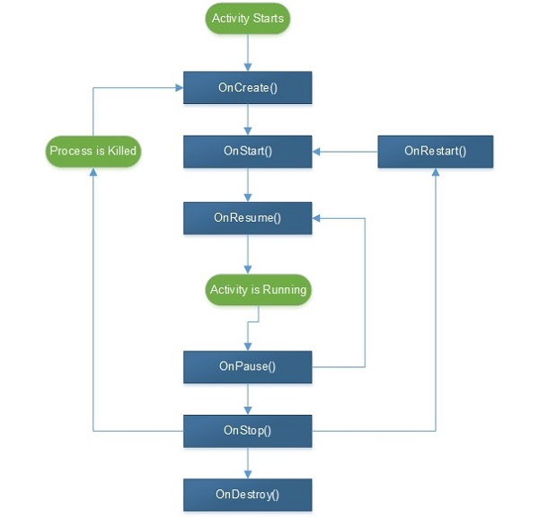

e. What are 5 different UI elements in an android app? One example is a “TextView”.

Some UI elements in an android app are :

* Buttons
* Edit Text
* Progress Bar
* Spinner (for a drop down menu)
* CheckBox

f. What are some of the salient features of those languages(part c)? How similar

are they to C++?

Java like C++ is an object oriented language but unlike c++ we can make use of tags. Its open source support is huge. (I found many sources on github coded in java). Though I found java codes a little difficult to understand as compared to other languages, still I have used java in my code because of a large number of tutorials available for java language.

Also Java and kotlin have more secure architecture.

Python is relatively simple but has a reputation of being slow. It is also object oriented but a lot more easy to understand for a beginner than C++.

XML is very similar to HTML and we can design activities graphically instead of writing code using Android studio.

# Tasks

1. Read about relative and linear layouts and how they are used to design the UI of Apps.

In relative view the position of each child view can be specified relative to sibling elements. In linear view all children view are aligned in a single direction (horizontal or vertical)

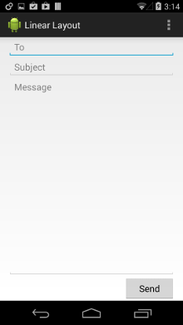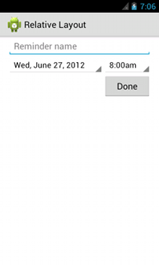

2. Now suppose you want to design the landing screen / dashboard of Book-ed!, what do you think should be the various features of that screen?

* I have gone through a number of classified apps. Most of the apps start with a splash screen (a short duration activity displaying the logo) followed by a one time login screen.
* The first activity after login should contain an explore search box.
* We can also add a list of suggestions (showing details and pictures of books) based on history/ ratings etc.
* The main activity should have buttons providing different options like Buy, Sell, Rent each of which is linked to their corresponding activity.
* The suggestions part can be further divided into themes like story, novels, reference books each of which can contain a list which can be scrolled horizontally (relative layout) (inspired from layouts of youtube website and play store)
* I have tried to integrate most of these features and some others in my dashboard code.

3. Draw a schematic diagram of the screen. You can do this using a pen and paper or use online android prototyping tools.

See index 4

4. Now break down your design into various layouts and elements. Clearly mark what is a linear layout, what are the various elements being used in your design. For example if there is a piece of text somewhere on the screen, that part would be the “TextView”.

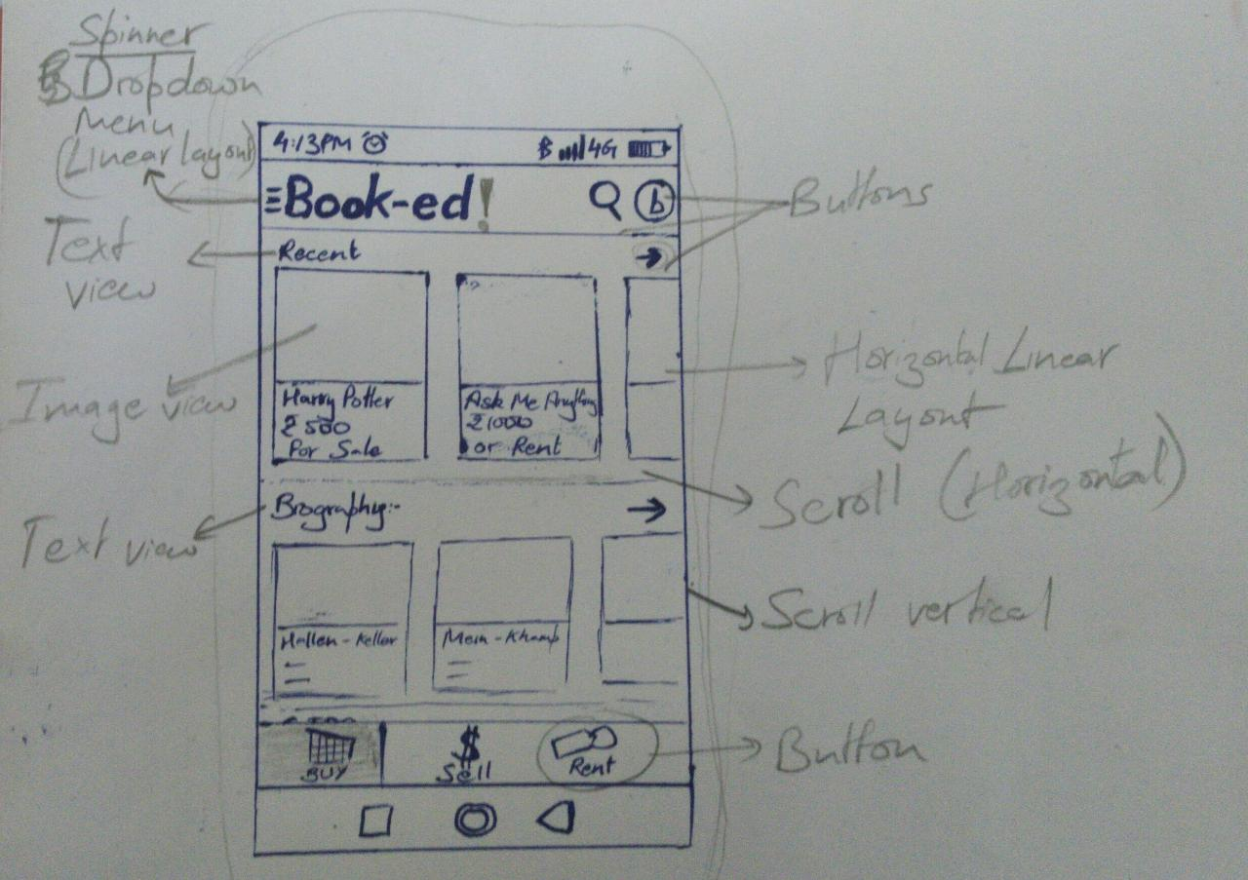

5. Install “Android Studio” on your laptop with all the necessary requirements and run

the starter app on your android device.

Status: Done

I am using the Java language because a wide variety of tutorials are available on the web.

6. Write the code for the dashboard which you just designed/prototyped.

Code uploaded to gethub.

https://github.com/bhavnoormarok/booked-.git